EV3 scanner

I sorted source/destination, protocol, length and info separately.
Then, I found that when info section is “Rcvd UIH Channel=1”, the data section looks almost the same for each packet, beside of some are “00 40”, some are “80 3f”. Seeing that it's a scanner on the white paper with black strokes, I deduced that’s the signal when scanning white and black. Moreover, it’s kinds of a car to scan, when meeting the end, the car reversed.(like S track)
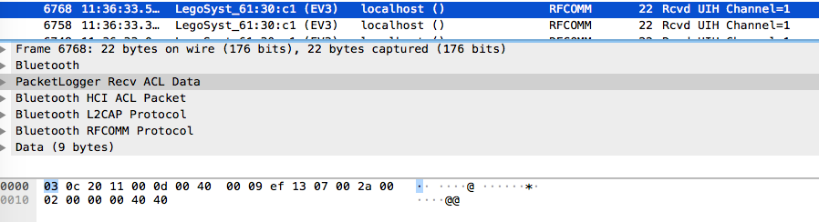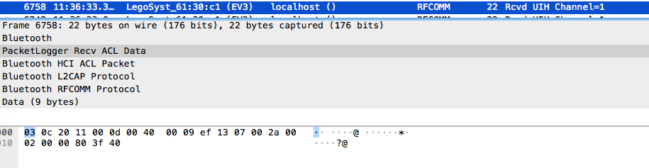

#different line
flagl0 = ""
flagl1 = ""
flagl2 = ""
...
for i in range(0, len(data)):
temp = "".join(data[i]["_source"]["layers"]["data"]["data.data"].split(":"))
#turn
if turn == 0:
flagl0 += " "
elif turn == 1:
flagl1 += " "
....

#put on mark
if detect == '80' and detect == '00':
if turn == 0:
flag10 += "#"
elif turn == 1:
flag11 += "#"
....
print (flag10)
print (flat11)
...

